**INTERNATIONAL UNIVERSITY - VIETNAM NATIONAL UNIVERSITY, HCMC**

**School of Computer Science & Engineering**

---------------  ---------------

PLANTS VS. ZOMBIES GAME

**OBJECT-ORIENTED PROGRAMMING**

First semester, 2020 – 2021

**Lecturer:** L.T.Son, N.Q.Phú

|  |  |  |
| --- | --- | --- |
| ***Group 12:*** | |  |
|  |  |  |
| ***Full name*** | | ***Student’s ID*** |
| TRẦN QUỲNH ANH | | ITDSIU18046 |
| NGUYỄN TRẦN KHÁNH DUY | | ITDSIU18049 |
| ĐẶNG QUANG HƯNG | | ITDSIU18035 |

**DETAILS**

This is a clone of the strategy video game, [Plants vs. Zombies](https://en.wikipedia.org/wiki/Plants_vs._Zombies), originally developed by PopCap Games.

Scope of our project: This is a single-player strategy game on the Windows platform. The game encourages creativity and daring via branching pathways. We are working mainly with object, animation, graphics, scripts, game engine facilities.

Development Tools and Programming Languages: Java, JavaFX.

**FEATURES**

* 5 Levels with increasing difficulties.
* Day mode only.
* Plants Available: Sunflower, Pea Shooter, Cherry Bomb, Walnut, Bloomerang.
* Zombies Available: Normal Zombie, Conehead Zombie.
* Save Game and Restart Game options.
* Cool sound effects.

**IMPLEMENTATION**

* Navigation via FXML files.
* **Load saved game** is used to load multiple saved states of the game.
* **Choose level** can be used for starting a new game from any level from level 1 to level 5.
* **Exit** is to exit the game.
* **In game menu**: allow user to exit to main menu
* The higher the level, the faster the zombies. Their frequency also increases.
* Different message on winning and losing a game.
* After placing a plant, a plant is locked for sometime before it can be planted again.
* Sun tokens fall from the sky beside produced by sunflowers.

**DIAGRAM****:** *in the GitHub link*

**DESIGN PATTERN**

Model View Controller

* Model: all classes and different functionality implementations.
* View: FXML (for GUI) files.
* Controller: It uses the model to make improvements to the view (or GUI).

Iterator to guarantee the synchronization of Plants, Zombies lists.

Menu-based implementation facade.

**SCREENSHOTS FROM THE GAME**

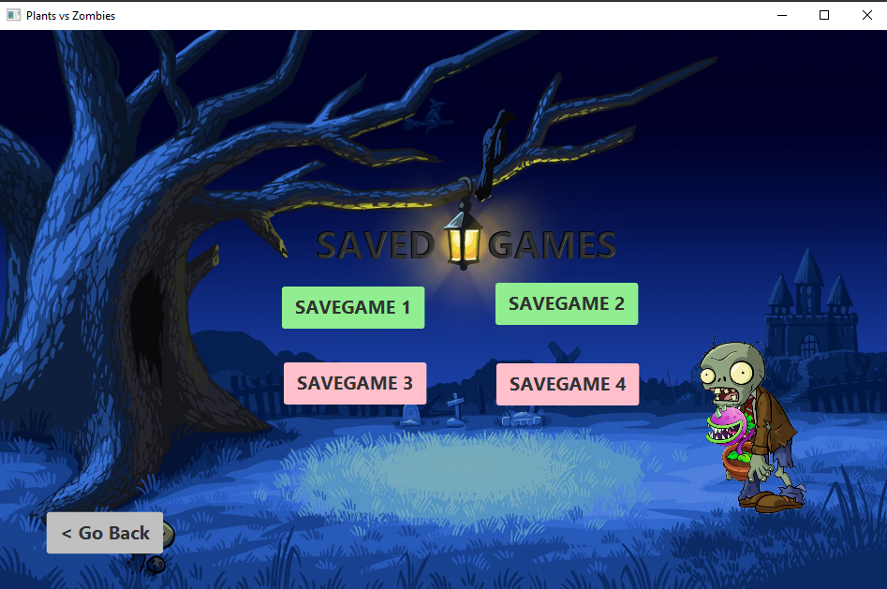

**CONCLUSION**

**Advantage:**

* Game can play, has 5 types of plant and 2 types of zombie.
* Separated into 5 level.
* Almost characters active.

**Disadvantage:**

* Game cannot be saved.
* Plant ‘Bloomerang’ has some problems.
* Some functions do not work well.